BE PROJECT..!!

TOPIC:

Transistor Amplifier CKT.

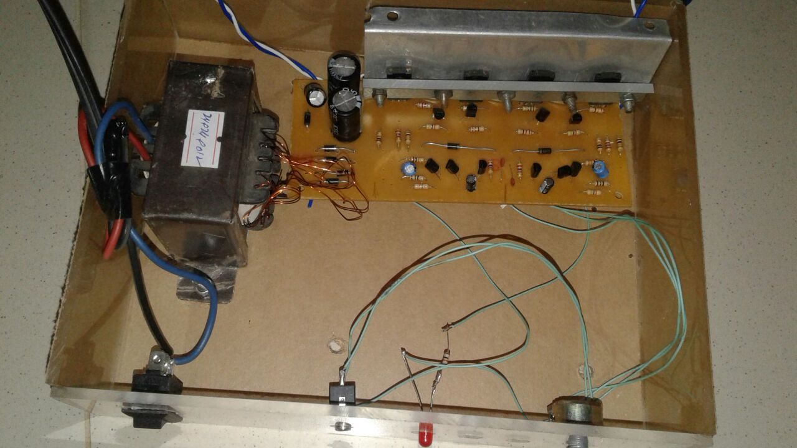

Team Members:

* Eisha 17k-3730
* Fatima 17k-3639
* Tabinda Qavi 17k-3909

AMPLIFIER:

“An electronic device for increasing the amplitude of electrical signals, used chiefly in sound reproduction

Components:

* **FOR DC SUPPLY**:
* Transformer (220V to 24V)
* Diode Bridge(4 diodes)
* Capacitors
* Switch
* **AMPLIFIER**:
* VR(variable resistor)
* Heat Sink
* Transistors
* Power Transistors
* Capacitors
* Resistors
* PCB (printed CKT board).

DC Power Supply:

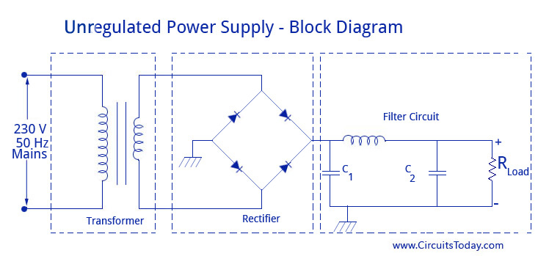

* DC voltage is used to operate the electronic device or circuit.
* The symbol for DC voltage is Vcc for most of the electronic circuit.
* It consists of:

1. Transformer.
2. Diode Bridge.
3. Filter capacitor.

CKT Diagram of amplifier:

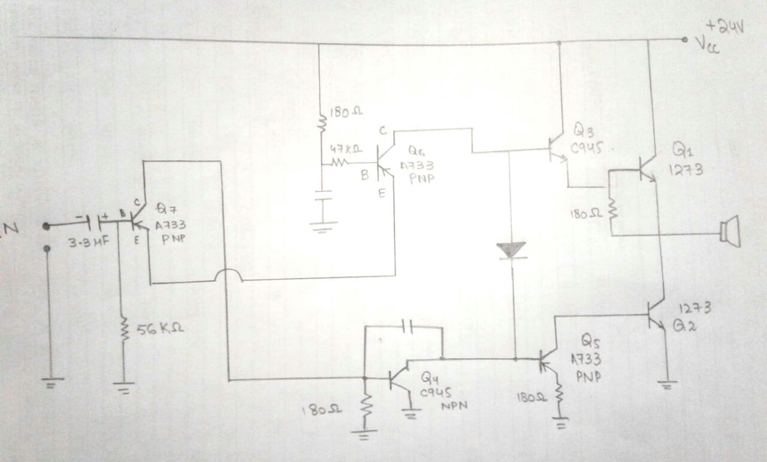

3 STAGES INVOLVED:

* Input Stage…Noise reduction.
* Pre-amplification…Gain stage.
* Power amplification...Output stage.
* The purpose of our amplifier is to produce an output signal larger than the input signal.

Thank you!